# 🍴 KUBE User Manual: Kitchen Utensil Borrowing Engine

This manual provides instructions for using the **KUBE (Kitchen Utensil Borrowing Engine)** application, a Python Tkinter program designed to manage kitchen utensil inventory, track borrowings, and monitor borrower history.

**I. System Overview and Initial Setup**

**KUBE** is designed to manage the full lifecycle of utensil inventory, from tracking stock to monitoring borrower reliability (Credit Score).

|  |  |
| --- | --- |
| **Feature** | **Description** |
| **Borrower Management** | Tracks individual users, contact details, and Credit Score. |
| **Credit Score** | Calculated automatically based on promptness and return condition (Late, Damaged, or Lost items reduce the score). |
| **Inventory** | Manages total quantity and available quantity for each item. |
| **Transaction Log** | Maintains a complete, time-stamped record of all borrowings and returns. |

**II. Access and Authentication**

**1. Launching and Logging In**

**[IMAGE PLACEHOLDER: Login Screen]**

1. Launch the KUBE application (execute kube.py).
2. Enter the **Username** and **Password** in the fields provided.
   * *Default Admin Credentials:* **Username: admin** | **Password: admin123**
3. Click the **"Login"** button to proceed to the Dashboard.

**2. Changing the Administrator Password**

1. From the Main Dashboard, click the **"🔑 Change Password"** button in the top right header.
2. Enter your **Current Password**.
3. Enter the **New Password**.
4. Enter the **Confirm New Password**.
5. Click **"Save"**.

**III. Main Dashboard and Navigation**

**[IMAGE PLACEHOLDER: Main Dashboard showing navigation menu and recent activity]**

The main screen provides an overview of system status and quick access to all modules via the Sidebar Menu on the left.

**A. Dashboard Overview**

* **Stats:** Displays key metrics like **Utensils Out** and **Overdue Items**.
* **Recent Activity:** Shows the last 10 transactions completed (Borrowed and Returned).

**B. Sidebar Menu Modules**

* **🏠 Dashboard:** Returns to the main overview screen.
* **📤 Borrow Utensils:** Starts a new borrowing transaction.
* **📥 Return Utensils:** Processes the return of active borrowings.
* **📜 Transaction Log:** View and export all historical records.
* **👥 Borrowers:** View user history and Credit Scores.
* **⚙️ Manage Equipment:** Add, edit, or delete inventory items.
* **⚙️ System Settings:** Adjust application-wide parameters (e.g., Max Borrow Limit).

**IV. Inventory Management**

Manage all kitchen utensils in the **"⚙️ Manage Equipment"** section.

**1. Adding New Inventory**

**[IMAGE PLACEHOLDER: Add New Utensil interface]**

1. Click **"⚙️ Manage Equipment"** in the Sidebar Menu.
2. Click the **"➕ Add New Utensil"** button.
3. Fill in the required fields:
   * **Name:** The item's common name (e.g., *Spatula*).
   * **Category:** (Optional) Grouping (e.g., *Serving Tools*).
   * **Total Quantity (Qty):** The total physical count of this item in stock.
4. Click **"Add"**.

**2. Updating Inventory**

1. Click **"⚙️ Manage Equipment"** in the Sidebar Menu.
2. Click the **"✏️ Edit Utensil"** button.
3. Select the item from the **Utensil** dropdown.
4. Adjust the **Name**, **Category**, or **New Quantity** as required.
   * *Note: The quantity cannot be reduced below the current number of items actively borrowed.*
5. Click **"✓ Update"**.

**V. Processing Transactions: Borrowing**

Use the **"📤 Borrow Utensils"** screen to record items leaving the inventory.

**[IMAGE PLACEHOLDER: Borrow Utensils screen]**

1. Navigate to **"📤 Borrow Utensils"**.
2. Fill in the **Borrower Information**:
   * **Borrower Name** (Required).
   * **Phone / Email** (Optional, but recommended for contact).
3. Set the **Due in (days)**. The system calculates the return date automatically.
4. In the **Select Items to Borrow** list:
   * Check the box next to the desired **Utensil**.
   * Set the specific **Qty** to be borrowed.
5. Click the **"🛒 Process Borrowing"** button.
   * *The system will block the transaction if the borrower has too many active items (Max Borrow Limit).*

**VI. Processing Transactions: Returning**

Use the **"📥 Return Utensils"** screen to receive items and update inventory/Credit Scores.

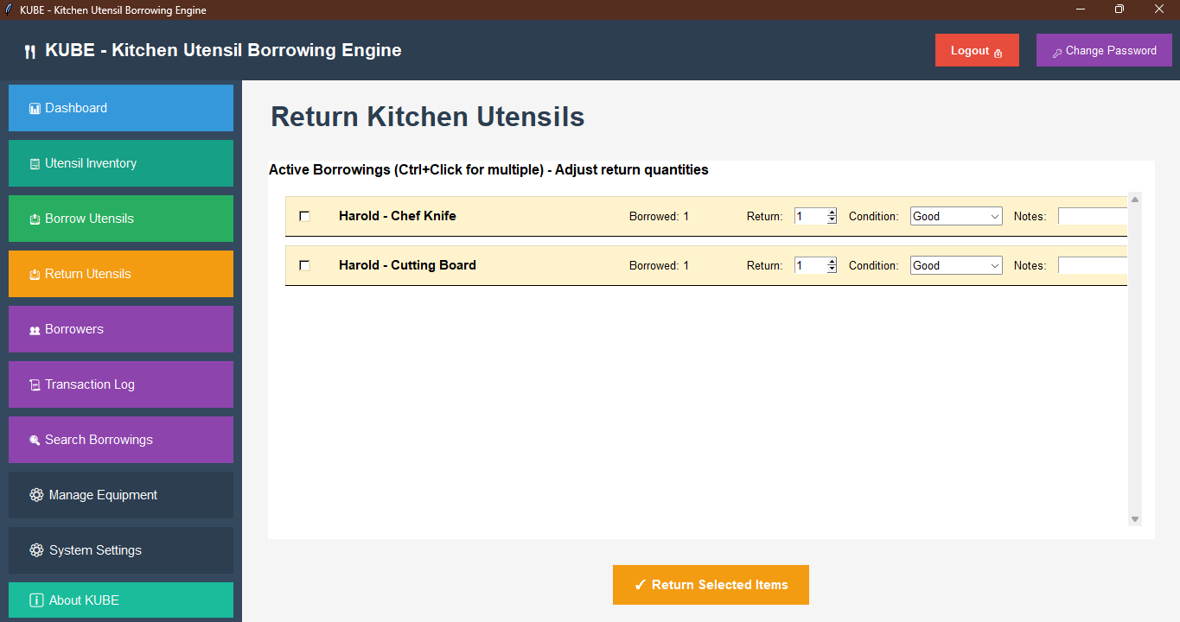

**[IMAGE PLACEHOLDER: Return Utensils screen]**

1. Navigate to **"📥 Return Utensils"**.
   * *The list displays all* ***Active Borrowings****. Overdue items are highlighted.*
2. Select the borrowing record you wish to process by **checking the box**.
3. Fill in the **Return Details**:
   * **Return Qty:** Specify the number being returned now (must be less than or equal to the borrowed amount).
   * **Condition:** Select the return condition (e.g., **Good, Damaged, Lost**). *Selecting Damaged or Lost will penalize the borrower's Credit Score.*
   * **Notes:** Add any relevant details about the return.
4. Click the **"✓ Process Return"** button. The inventory and borrower's record are updated.

**VII. Advanced Management and Reporting**

**1. Borrower Credit Score and History**

1. Navigate to **"👥 Borrowers"**. The list shows all users and their current **Credit Score**.
2. To see full history, select a borrower and click **"👁️ View Details"**.
3. The detail view includes contact info, borrowing statistics, and a full log of all their transactions.

**2. Transaction Log and Export**

1. Navigate to **"📜 Transaction Log"**.
2. Review the complete history of all borrowing and return actions.
3. Click the **"Export to CSV"** button to save the entire log as a spreadsheet file for external reporting.

**3. System Settings**

1. Navigate to **"⚙️ System Settings"**.
2. Change the **Maximum Borrow Limit per Person** by entering a new number.
3. Click **"Save Settings"**. This limit prevents users from checking out more than the specified number of items at one time.